**MESD LMS Documentation - View/print/download Teacher Analysis**

**Purpose**

Allow the school head to monitor and evaluate the performance of the teachers in their school. Teachers will create a feedback/survey activity which learners will answer. The school head will view the results of the activities.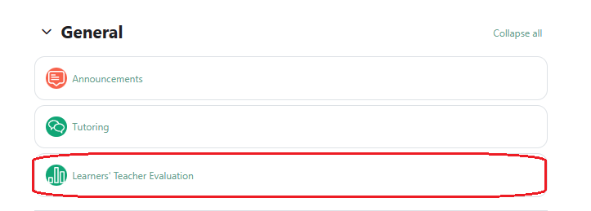

To make this possible the following capabilities were added:

* mod/survey:download
* mod/survey:readresponses
* mod/feedback:viewanalysepage
* mod/feedback:viewreports
* mod/feedback:view

Feedback activities and surveys are used to evaluate teachers. This documentation was done assuming learning institutions will create their own questions to ask learners for teacher evaluation.

**Usage**

1. Log in as **School head**.
2. Open your block drawer.

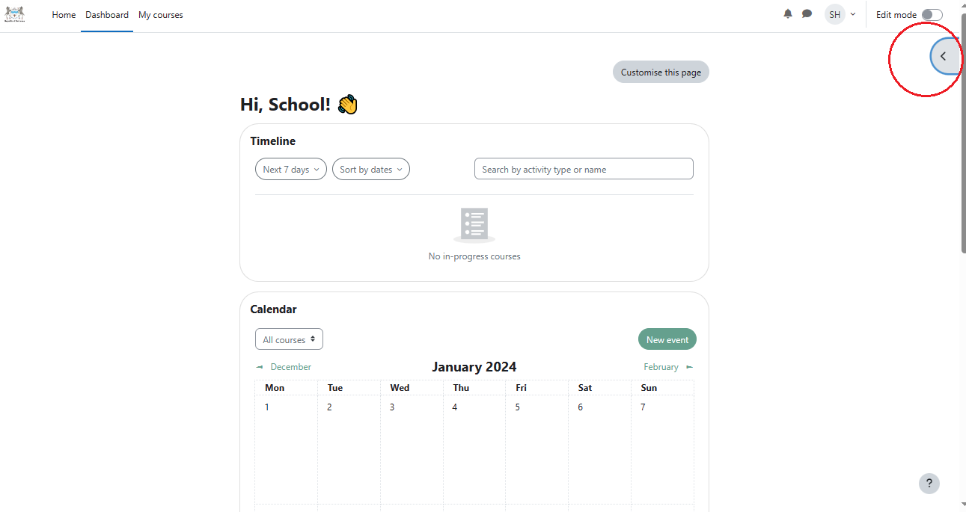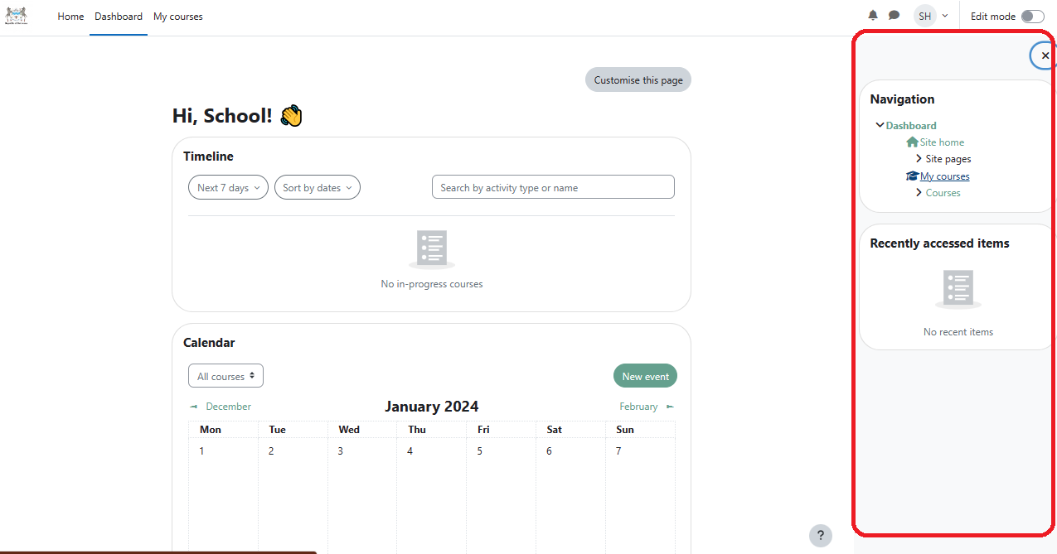

1. Double click on **Courses.**
2. Select the subject/course you’d like to view a teacher analysis.
3. Click on the feedback/survey activity.



1. For surveys:

* Click on **Response reports**.

To download results click on **Download results** around the top right corner of the page.

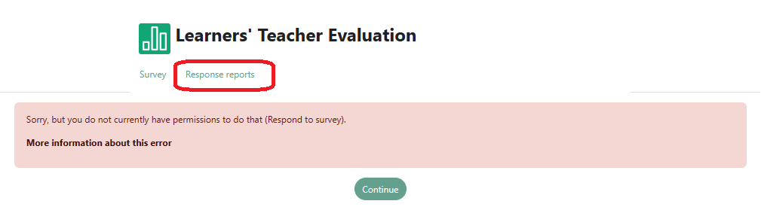

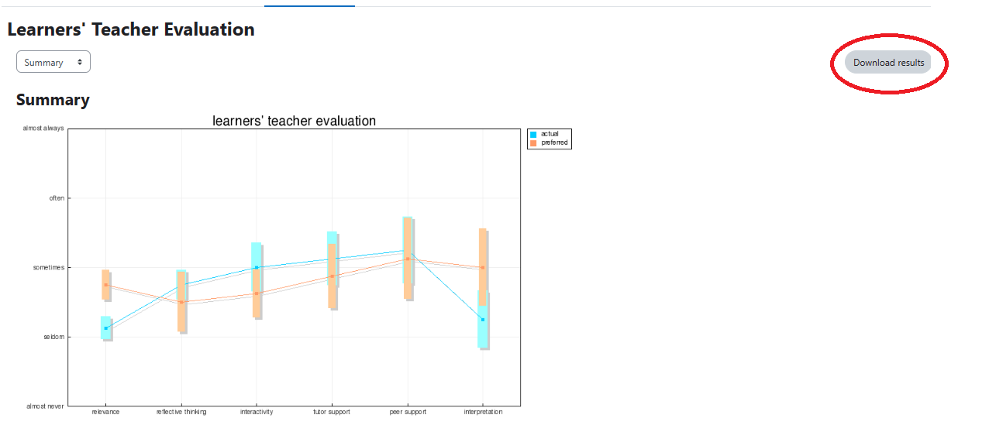

For feedback:

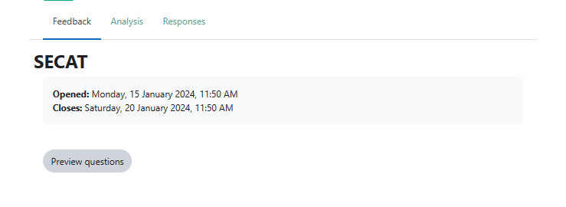

* Click **Analysis** to get a visual representation of the results.

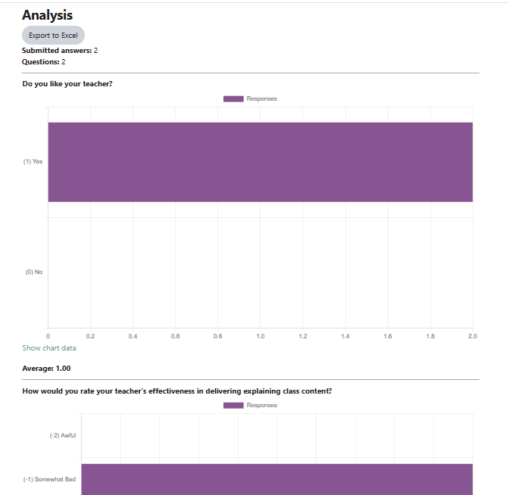

Click **Export to Excel** to download table data.

* Click **Responses** to view responses.

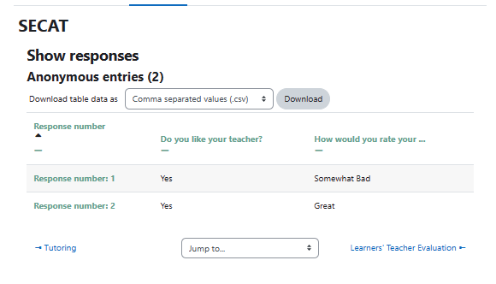

To download choose what file you’d like to download the table data as and click **Download**.